

|  |
| --- |
| FPT  Jira Clone  Software |
| **User’s manual** |
| **July 6**  FPT Jira Clone Software  Authored by: Team 1 Fr.net 23_01 |



**Content Table**

1. DOCUMENT HISTORY 3

2. INTRODUCE 3

2.1 Purpose 3

2.2 Applied Range 4

3. FUNTIONAL DESCRIPTION 5

3.1 Login for Admin: 5

3.2 Login for User: 6

3.3 System management for Admin: 7

*3.3.1* *Component management.* 7

*3.3.2* *Project management.* 12

*3.3.3* *User management* 16

*3.3.4* *Product management* 21

3.4 Issue management: 25

*3.4.1* *View Issue Lists* 25

*3.4.2* *Search issue* 26

*3.4.3* *Export issues in Excel and HTML Format* 27

*3.4.4* *Create new Issue* 27

*3.4.5* *View issue’s detail* 28

*3.4.6* *Export Issue detail* 29

*3.4.7* *Edit issue’s information* 30

*3.4.8* *Change the Issue’s workflow status.* 31

*3.4.9* *Start/ Stop watching the issue.* 33

3.5 Personal profile management: 34

*3.5.1* *View personal information* 34

*3.5.2* *Change password* 35

4. APPENDIX 36

# DOCUMENT HISTORY

|  |  |  |
| --- | --- | --- |
| **Date** | **Summary of Changes** | **Version** |
| 03/7 | Create SRS | 1 |
| 31/1 | * Update use case diagram * Update System flow | 2 |
| 22/2 | * Update Functional Description | 3 |

# INTRODUCE

## Purpose

Jira Software is a widely used project management tool developed by Atlassian. It is designed to help teams plan, track, and manage their work effectively. Here are some key points about Jira Software:

* Issue Tracking: Jira Software primarily focuses on issue tracking. It allows teams to create, prioritize, assign, and track issues or tasks throughout their lifecycle. Issues can be anything from bug reports and feature requests to user stories and technical tasks.
* Agile Methodologies: Jira Software supports various Agile methodologies such as Scrum and Kanban. It provides features like customizable Scrum and Kanban boards, backlogs, sprints, and swimlanes to help Agile teams manage their work and visualize their progress.
* Workflow Management: Jira Software allows you to create custom workflows to reflect your team's unique processes. Workflows define the steps an issue goes through from creation to completion, including states, transitions, and conditions. This flexibility enables teams to adapt Jira to their specific needs.
* Collaboration and Communication: Jira Software encourages collaboration within teams. It provides features like comments, mentions, attachments, and activity streams that allow team members to communicate, share information, and collaborate on issues effectively:
* Integration and Extensibility: Jira Software integrates with a wide range of development and collaboration tools. It offers an extensive marketplace where you can find add-ons and extensions to enhance its functionality. Additionally, Jira Software has a robust REST API, allowing you to build custom integrations and automate workflows.
* Reporting and Analytics: Jira Software provides reporting and analytics capabilities to help teams monitor their progress, identify bottlenecks, and make data-driven decisions. It offers built-in reports such as burndown charts, velocity charts, and control charts, and also allows you to create custom reports and dashboards.
* Scalability: Jira Software is suitable for teams of all sizes, from small startups to large enterprises. It can handle thousands of issues and users concurrently and can be scaled horizontally by adding additional nodes to support increased load and performance.
* Cloud and Self-hosted Options: Jira Software is available as a cloud-based service (Atlassian-hosted) or as a self-hosted solution (server or data center). The cloud version offers easy setup, automatic updates, and scalability, while the self-hosted options provide more control over the infrastructure

## Applied Range

Jira Software is a versatile tool that can be applied to a wide range of industries and teams. Here are some common areas where Jira Software is used:

* Software Development: Jira Software was originally developed for software development teams, and it remains a popular choice in this industry. It helps teams manage software projects, track bugs and issues, plan and execute Agile methodologies, and collaborate effectively.
* IT Service Management (ITSM): Jira Software can be utilized for IT service management, including incident management, problem management, change management, and service request management. It helps IT teams streamline their workflows, track issues, and ensure efficient service delivery.
* Project Management: Jira Software is widely adopted as a project management tool outside the software industry as well. It allows project managers to plan, track, and manage tasks, deadlines, and resources across different projects.
* Marketing and Creative Teams: Marketing and creative teams often use Jira Software to manage their campaigns, content creation, and design projects. It enables teams to track tasks, collaborate on creative assets, and maintain an overview of project progress.
* HR and Recruitment: Jira Software can be used by HR departments and recruitment teams to streamline their hiring processes. It helps track candidate profiles, manage interviews, collaborate on candidate feedback, and monitor the overall recruitment pipeline.
* Operations and Support: Jira Software is valuable for operations and support teams, enabling them to track and manage incidents, handle service requests, and maintain a knowledge base for troubleshooting and resolving issues.
* Education and Research: Jira Software is also utilized in the education and research sectors. It can be used to manage research projects, track experiments, collaborate on academic papers, and coordinate activities within educational institutions.

# FUNTIONAL DESCRIPTION

## Login for Admin:

* This is the log in page screen of Jira system.

* Enter Admin Account and Password, click Login. (Note: Account and Password will be provided by the direct superior management unit.)

* When successfully logged in with admin account, User will be navigated to admin management screen.

## Login for User:

* Enter Account and Password, click Login. (Note: Account and Password will be provided by the direct superior management unit.)

* When successfully logged in with user account, User will be navigated user’s home screen:

## System management for Admin:

### *Component management.*

#### View Component List

* Select the ‘Manage component’ item on the siderbar to go to the Component Management page.

* After clicking, it will go to the component management page showing the list of components as shown:

#### Search Components

* At the component list display screen, click on the search icon next to the column name component name.
* After clicking, a search input will appear to enter value.

* After entering search input, press enter, will display a list of components matching the search value, otherwise an empty list will be returned.

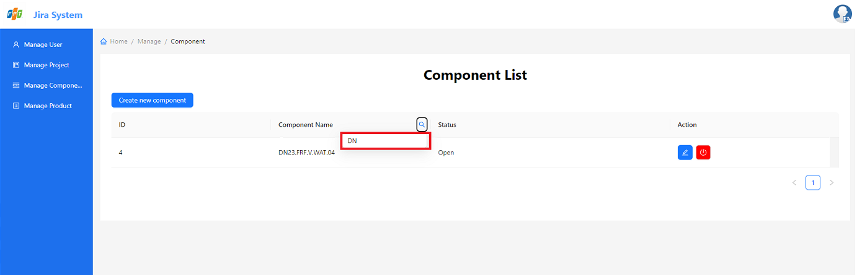

#### Create New Component

* To create a new component, click on the ‘Create new component’ button

* After clicking, it will pop up Create Modal to create a new component.

* Enter the name of the component and press ‘Add new’ button.

Note:

Component name must not be blank and must be different from the component name that already exists in the list.

* If the component is added successfully, Create Modal will pop off.
* Display a successful addition message and update the list again.

#### Update Component

* Click on the edit icon of the record to edit the record.

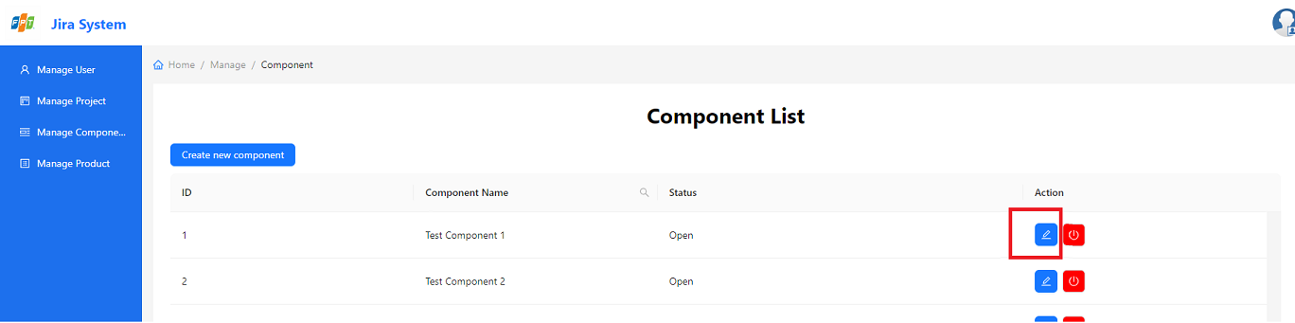

* After clicking, it will pop up Edit Modal to edit the component.

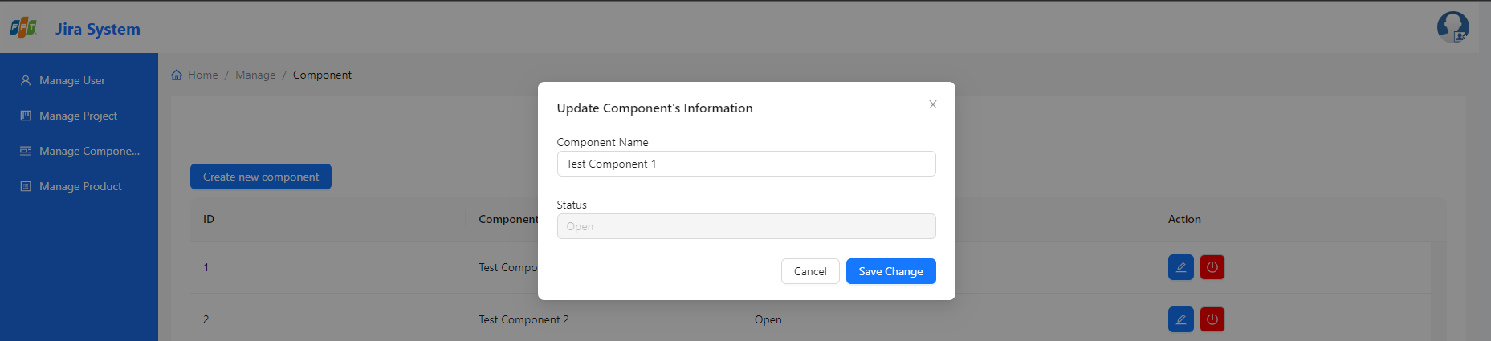

* Fill in the fields you want to edit the component and click ‘Save changes’ button.

Note:

Component name must not be blank, and must be different from the component name that already exists in the list.

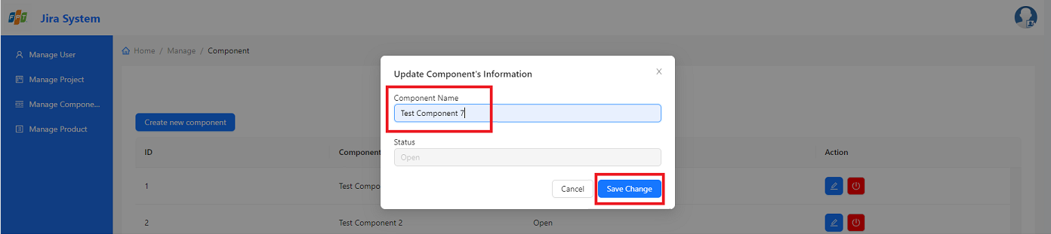

* If the component is edited successfully, Edit Modal will pop off.
* Display a successful edition message and update the list again.

#### Close/Open Component

* Click the button to change the status to close/open the component.

Note:

‘Green’ button is ‘Open status component’ and ‘Red button’ is ‘Close status component’

* After clicking the close/open button, the Confirm Modal will pop up

Note:

When clicking the close button, Confirm Modal will be:

When clicking the open button, Confirm Modal will be:

* Press ‘Ok’ button, Confirm Modal will pop off.
* Display a notification message and update the list again.

### *Project management.*

#### View Project List

* Select the ‘Manage project’ item on the siderbar to go to the Project Management page.

* After clicking, it will go to the project management page showing the list of projects as shown:

#### Search Projects

* At the project list display screen, click on the search icon next to the column name ‘Project name’ or ‘Short name’.
* After clicking, a search input will appear to enter.

* After entering search input, press enter, will display a list of projects matching the search value, otherwise an empty list will be returned.

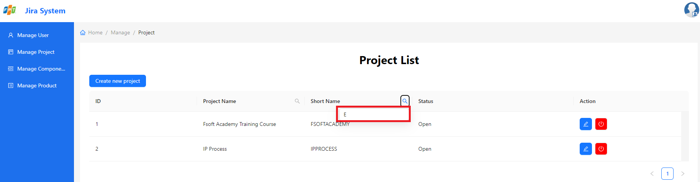

#### Create New Project

* To create a new project, click on the ‘Create new project’ button

* After clicking, it will pop up Create Modal to create a new project.

* Fill in the fileds of project and press ‘Add new’ button.

Note:

Project name and Short Name must not be blank, and must be different from the project name that already exists in the list.

* If the project is added successfully, Create Modal will pop off.
* Display a successful addition message and update the list again.

#### **Update Project**

* Click on the edit icon of the record to edit the record.

* After clicking, it will pop up Edit Modal to edit the project.

* Fill in the fields you want to edit the project and click ‘Save changes’ button.

Note:

Project name and Short Name must not be blank, and must be different from the project name that already exists in the list.

* If the project is edited successfully, Edit Modal will pop off.
* Display a successful edition message and update the list again.

#### **Close/Open Project**

* Click the button to change the status to close/open the project.

Note:

‘Green’ button is ‘Open status component’ and ‘Red button’ is ‘Close status component’

* After clicking the close/open button, the Confirm Modal will pop up

Note:

When clicking the close button, Confirm Modal will be:

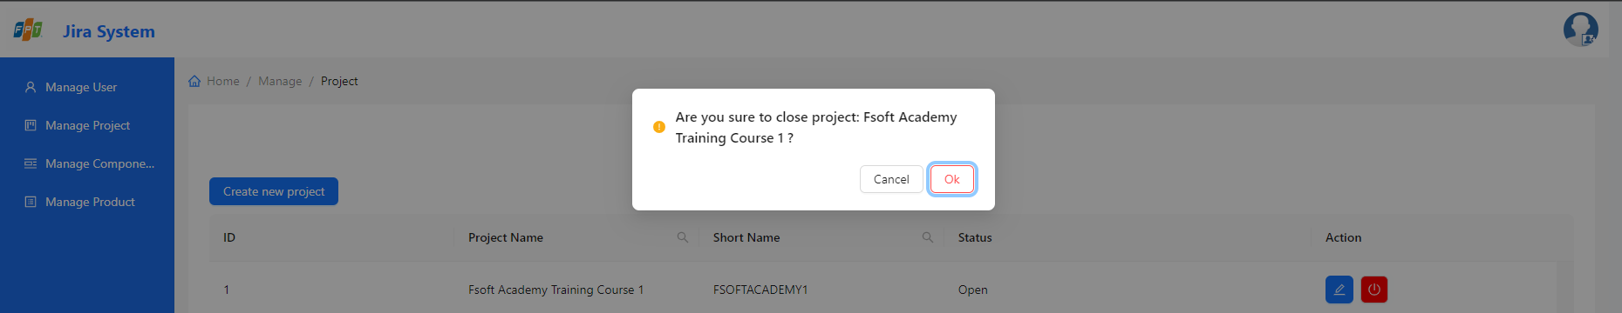

When clicking the open button, Confirm Modal will be:

* Press ‘Ok’ button, Confirm Modal will pop off.
* Display a notification message and update the list again.

### *User management*

#### View User List

* Select the ‘Manage user’ item on the siderbar to go to the User Management page.

* After clicking, it will go to the user management page showing the list of users as shown:

#### Search Users

* At the user list display screen, click on the search icon next to the column name ‘Full Name’ or ‘Email’ or ‘Account’.
* After clicking, a search input will appear to enter.

* After entering search input, press enter, will display a list of users matching the search value, otherwise an empty list will be returned.

#### Create New User

* To create a new user, click on the ‘Create new user’ button

* To create users by excel file, clicl on the ‘Upload Users’ button.

* After clicking, it will pop up Create Modal to create a new users.

* Fill in the fileds of user and press ‘Add new’ button.

Note: Full Name, Email, BirthDay must not be blank, and must be different from the email that already exists in the list, BirthDay must be smaller than the current day and must be older than 18 years old.

* If the project is added successfully, Create Modal will pop off.
* Display a successful addition message and update the list again.

#### Update User

* Click on the edit icon of the record to edit the record.

* After clicking, it will pop up Edit Modal to edit the project.

* Fill in the fields you want to edit the user and click ‘Save changes’ button.

Note:

Full Name, Email, BirthDay must not be blank, and must be different from the email that already exists in the list, BirthDay must be smaller than the current day and must be older than 18 years old.

* If the project is edited successfully, Edit Modal will pop off.
* Display a successful edition message and update the list again.

#### Activated/Deactivated User

* Click the button to change the status to Activated/Deactivated the user.

Note:

‘Green’ button is ‘activated status user’ and ‘Red button’ is ‘deactivated status user’

* After clicking the Activated/Deactivated button, the Confirm Modal will pop up

Note:

When clicking the Activated button, Confirm Modal will be:

When clicking the deactivated button, Confirm Modal will be:

* Press ‘Deactivated’/ ‘Activated’ button, Confirm Modal will pop off.
* Display a notification message and update the list again.

### *Product management*

#### View Product List

* Select the ‘Manage product’ item on the siderbar to go to the Product Management page.

* After clicking, it will go to the product management page showing the list of products as shown:

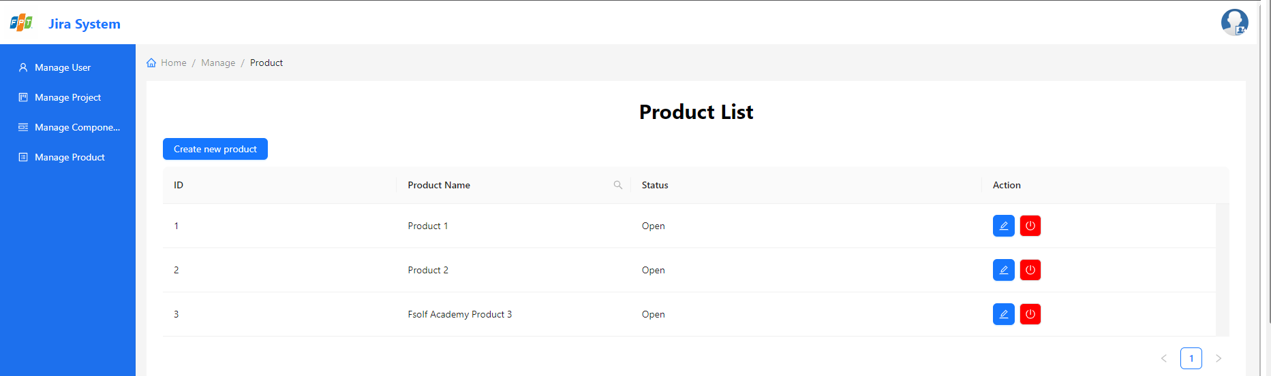

#### Search Products

* At the product list display screen, click on the search icon next to the column name ‘Project name’
* After clicking, a search input will appear to enter.

* After entering search input, press enter, will display a list of projects matching the search value, otherwise an empty list will be returned.

#### Create New Product

* To create a new product, click on the ‘Create new product’ button

* After clicking, it will pop up Create Modal to create a new product.

* Fill in the fileds of product and press ‘Add new’ button.

Note: Product name must not be blank, and must be different from the product name that already exists in the list.

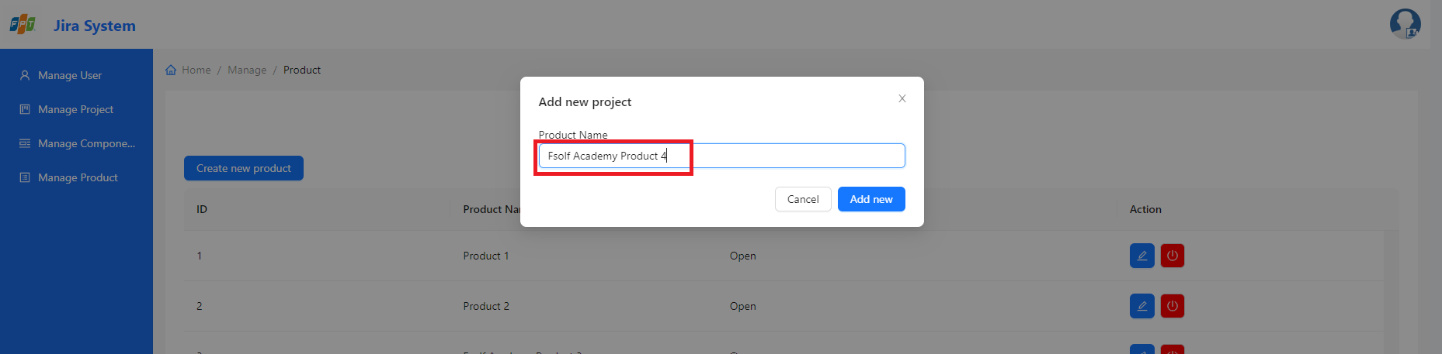

* If the project is added successfully, Create Modal will pop off.
* Display a successful addition message and update the list again.

#### Update Product

* Click on the edit icon of the record to edit the record.

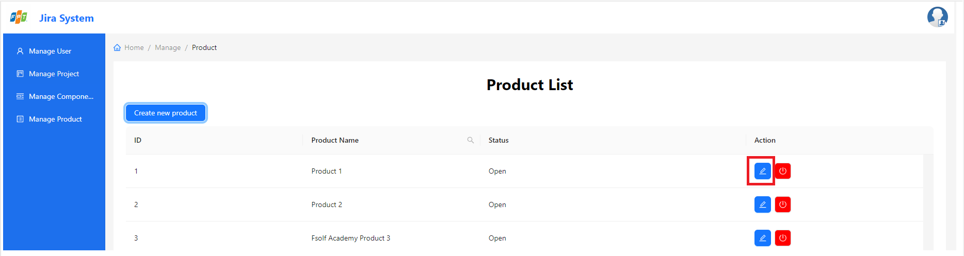

* After clicking, it will pop up Edit Modal to edit the product.

* Fill in the fields you want to edit the product and click ‘Save changes’ button.

Note:

Product name must not be blank, and must be different from the product name that already exists in the list.

* If the product is edited successfully, Edit Modal will pop off.
* Display a successful edition message and update the list again.

#### Close/Open Product

* Click the button to change the status to close/open the product.

Note:

‘Green’ button is ‘Open status product’ and ‘Red button’ is ‘Close status product’

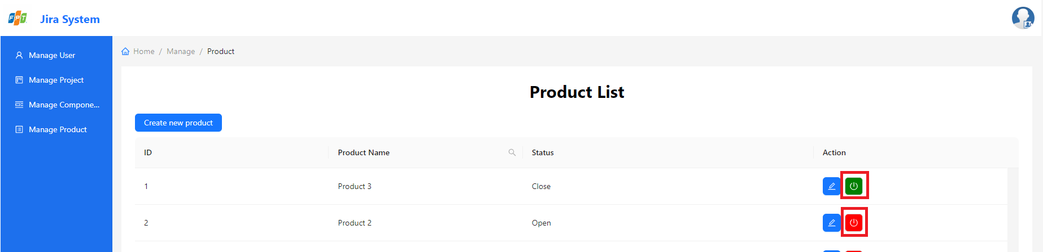

* After clicking the close/open button, the Confirm Modal will pop up

Note:

When clicking the close button, Confirm Modal will be:

When clicking the open button, Confirm Modal will be:

* Press ‘Ok’ button, Confirm Modal will pop off.
* Display a notification message and update the list again.

## Issue management:

After logging in the system bu User account, this function will help user to interact with issus in different ways.

### *View Issue Lists*

* Select Issue (1) on navbar and then go to More…(2) to access to the Issue List.

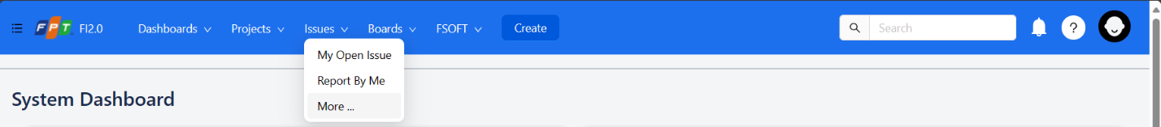

* The screen will display the list of issues sorted by categories: My open issues, Reported by me, All Issues, Open Issues.

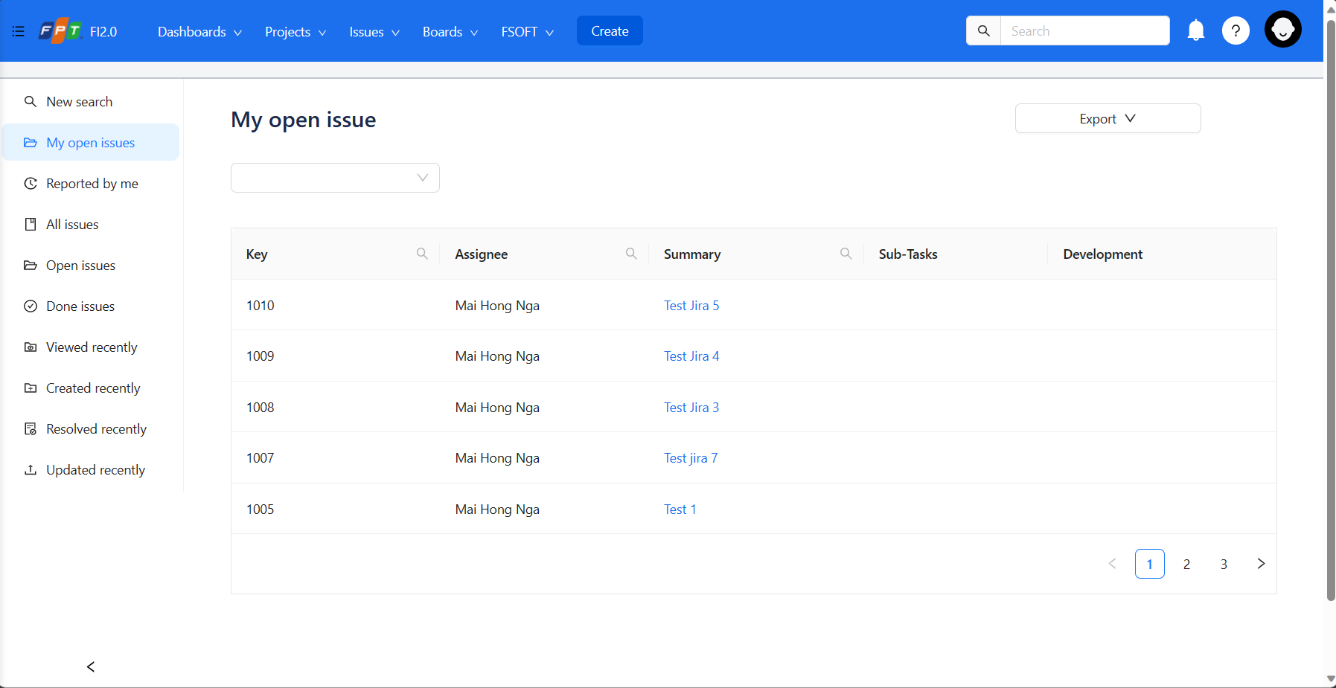

### *Search issue*

* In the Issue List screen, if user wants to search the issues by Componet, click on Component dropdown list to sort issues users want to find.
* The list will show the issues that belong to the chosen component.

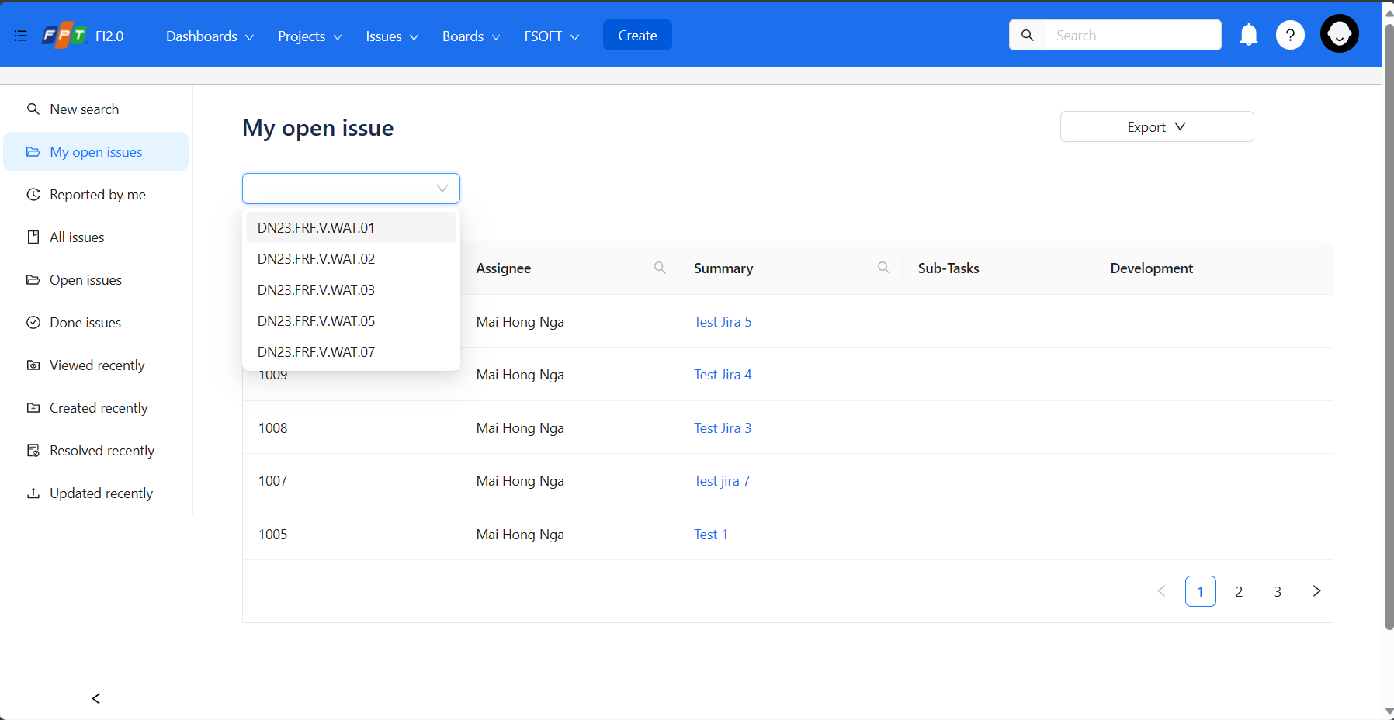

* On the issue list, user can search the issues by Key, Assignee, Summary…
* The list will show the issues that belong to the given values in Key, Assignee, Summary textbox.

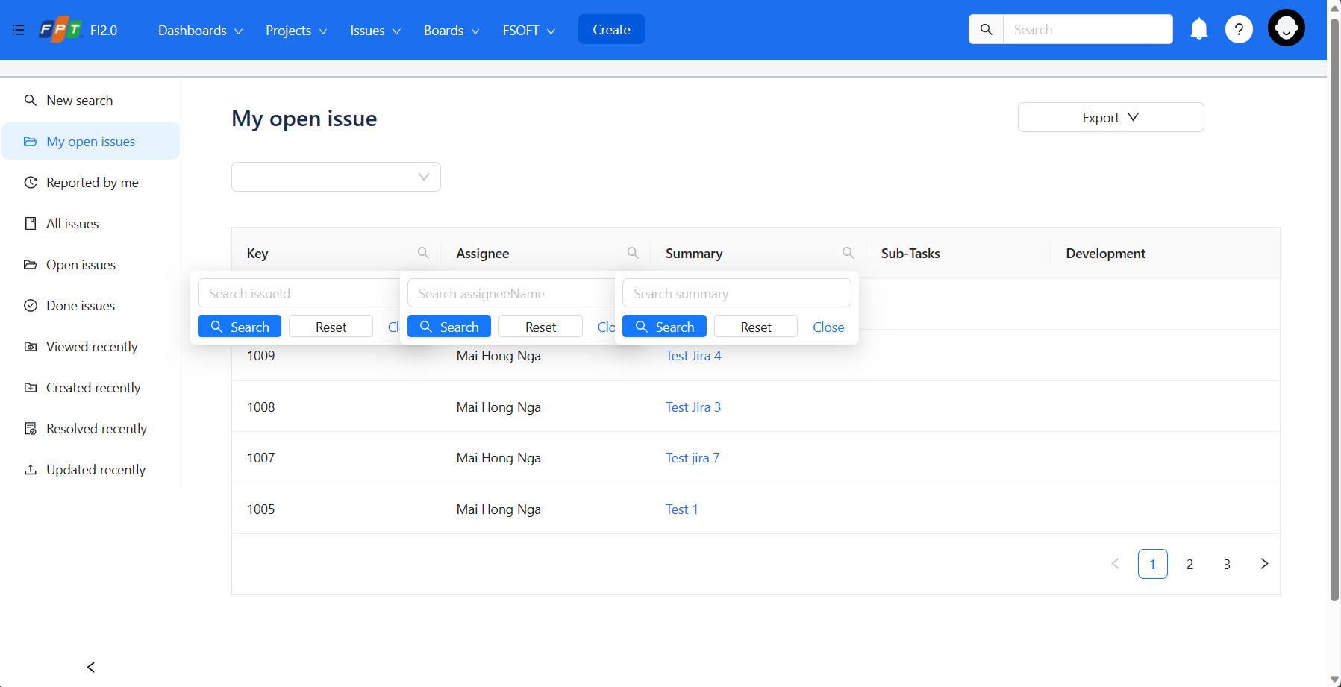

### *Export issues in Excel and HTML Format*

* If user want to export the issues in Excel or HTML format, Click on the Export button to choose the format to download.

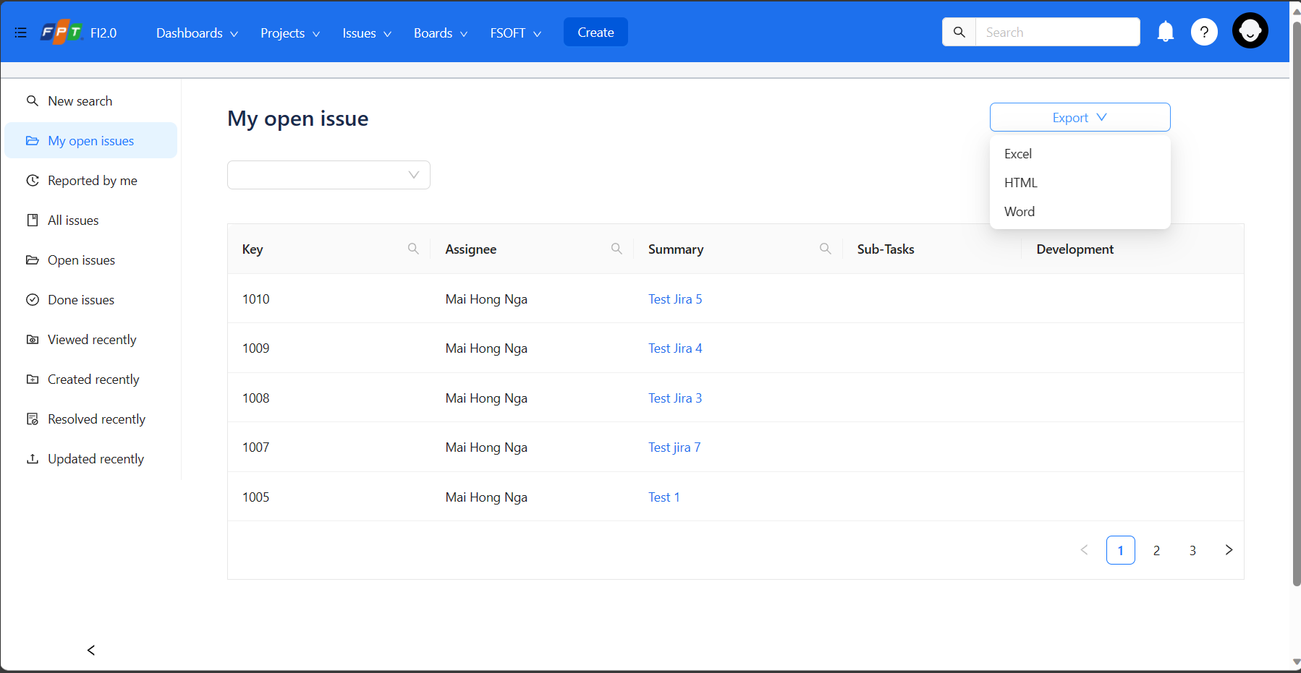

### *Create new Issue*

Create new Issue in system.

* On the issue list screen, Click on Create button on navbar to show the modal for creating new Issue.
* 

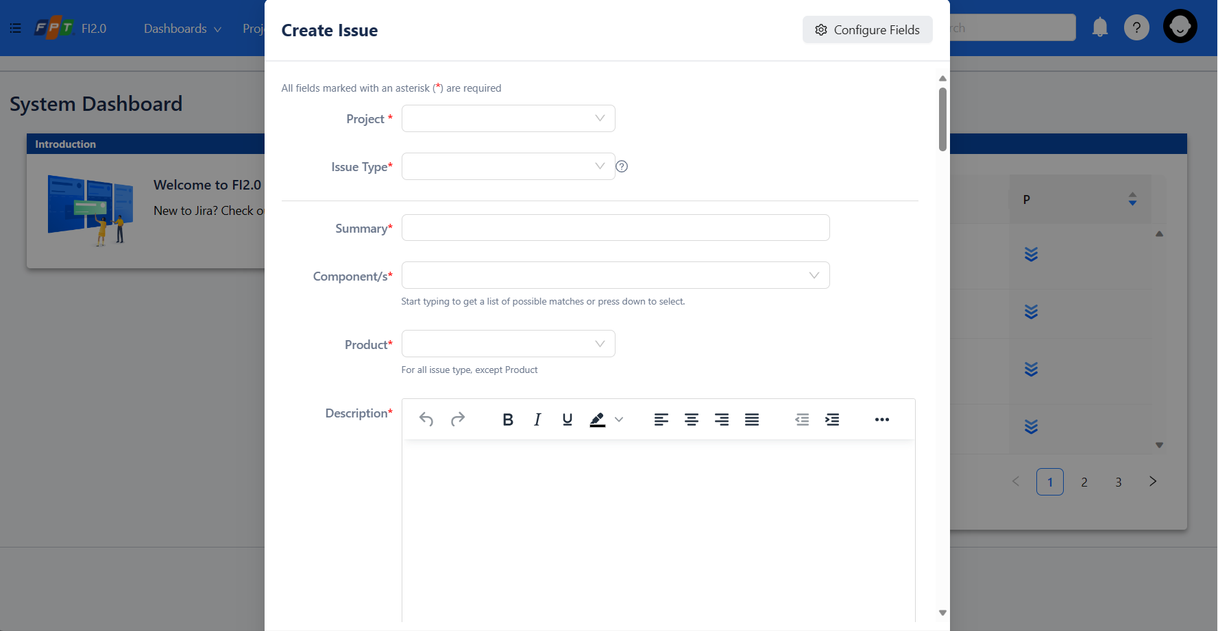

* Fill all the fieds in the modal, click on Create to save the new Issue to the system.

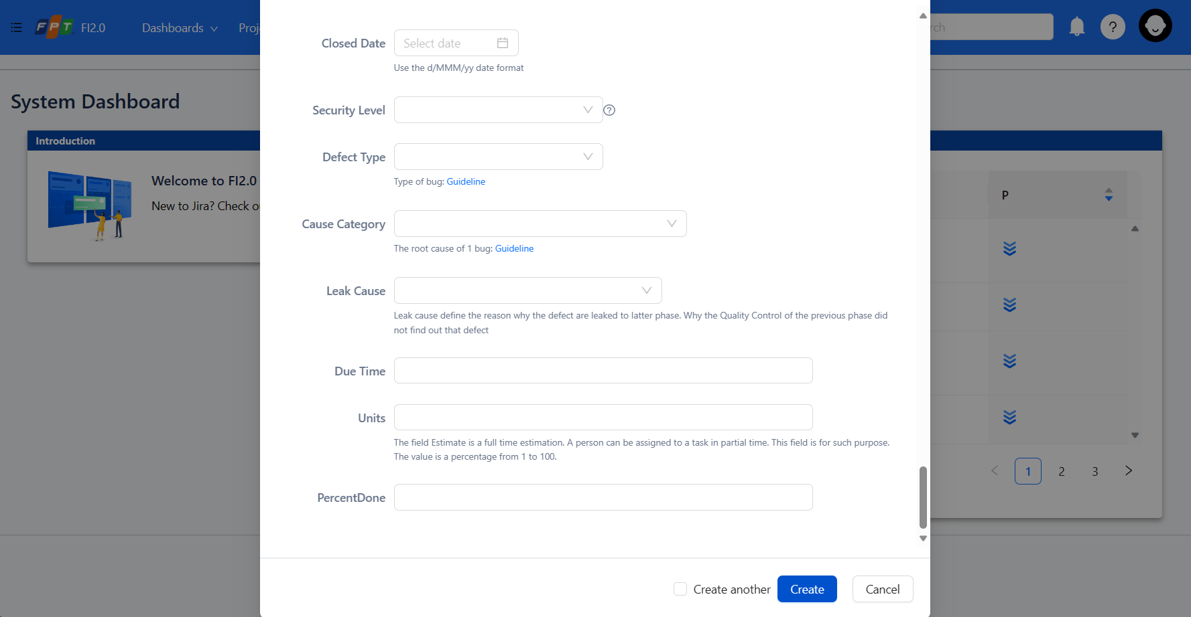

Note:

All the required fields must be filled to create issue successfully, if user do not fill the required fields, errors will occur and can not create an issue.

### *View issue’s detail*

* On the issues list screen, click on the Issue user want to see the detail.



* On the detail screen, User can view the fields of issue and interact with issues detail’s information.

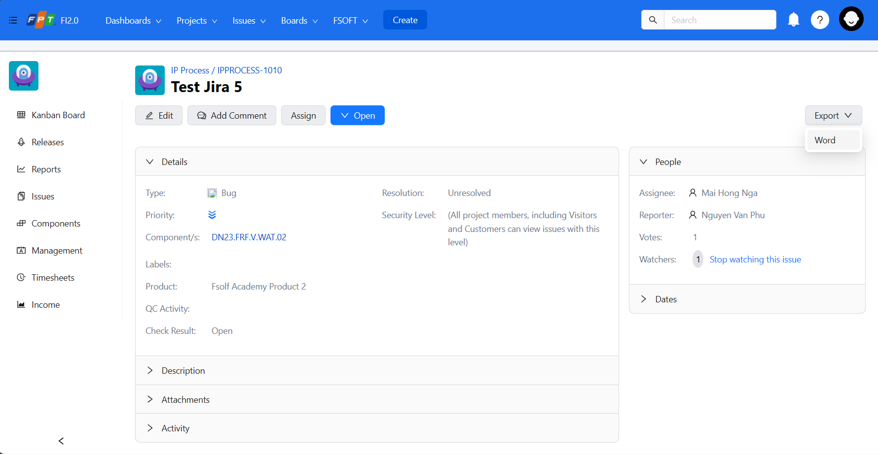

### *Export Issue detail*

* User can export the issue in the Microsoft Word format to view or use it for printatble purpose.
* On the Issue detail screen, Click on Export button, choose the Word option to download the Doc format of Issue.



### *Edit issue’s information*

* On the Detail Issue screen, Click on the Edit button to pop up the modal of Issue Detail information to Edit.

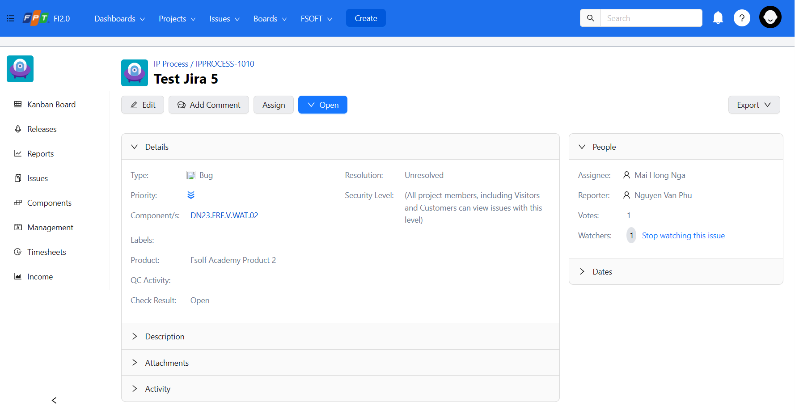

* After editing the issue Click on the Update Button to save the changes.

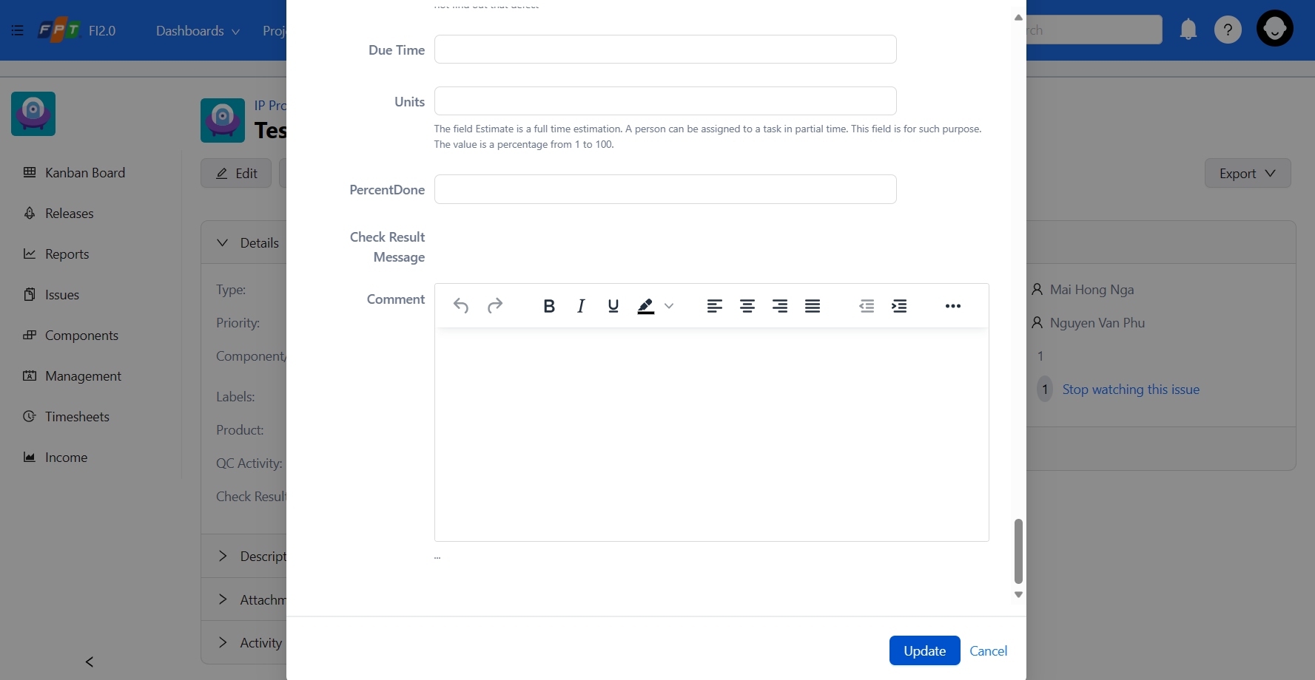

### *Change the Issue’s workflow status.*

* On the Detail Issue screen, click on Open button to choose the work flow status User want the issue’s status to change.
* As Click on Open button, the list of status will dropdown.

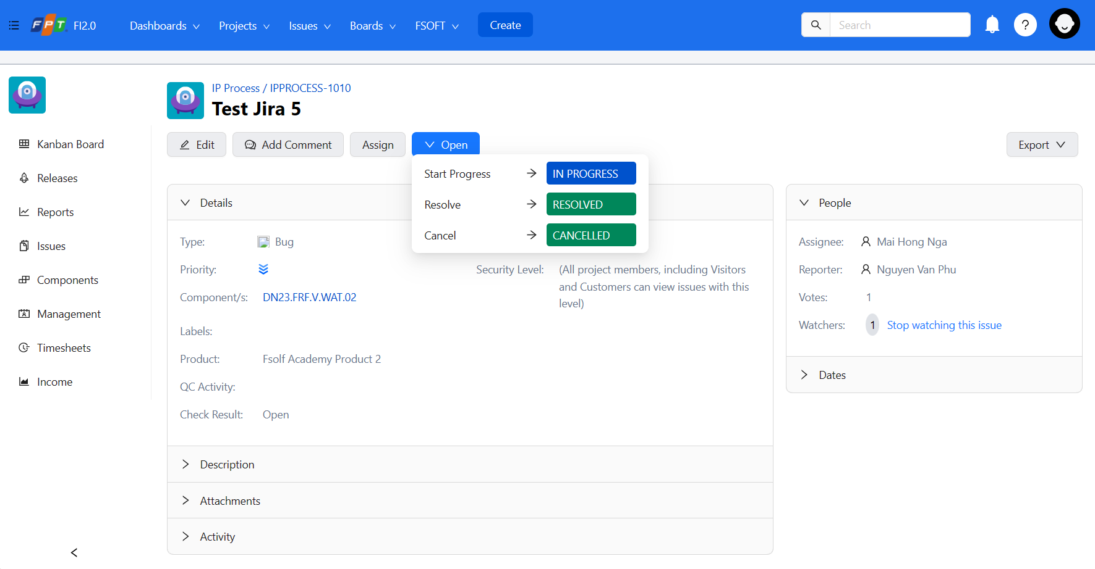

#### *Change the issue’s workflow status to Resolved.*

* Ass User click on Resolves button on Issue’s workflow status list, a modal of issue’s resolved status will show up for User to fill.



* After filling information, click on the Resolve button to save.

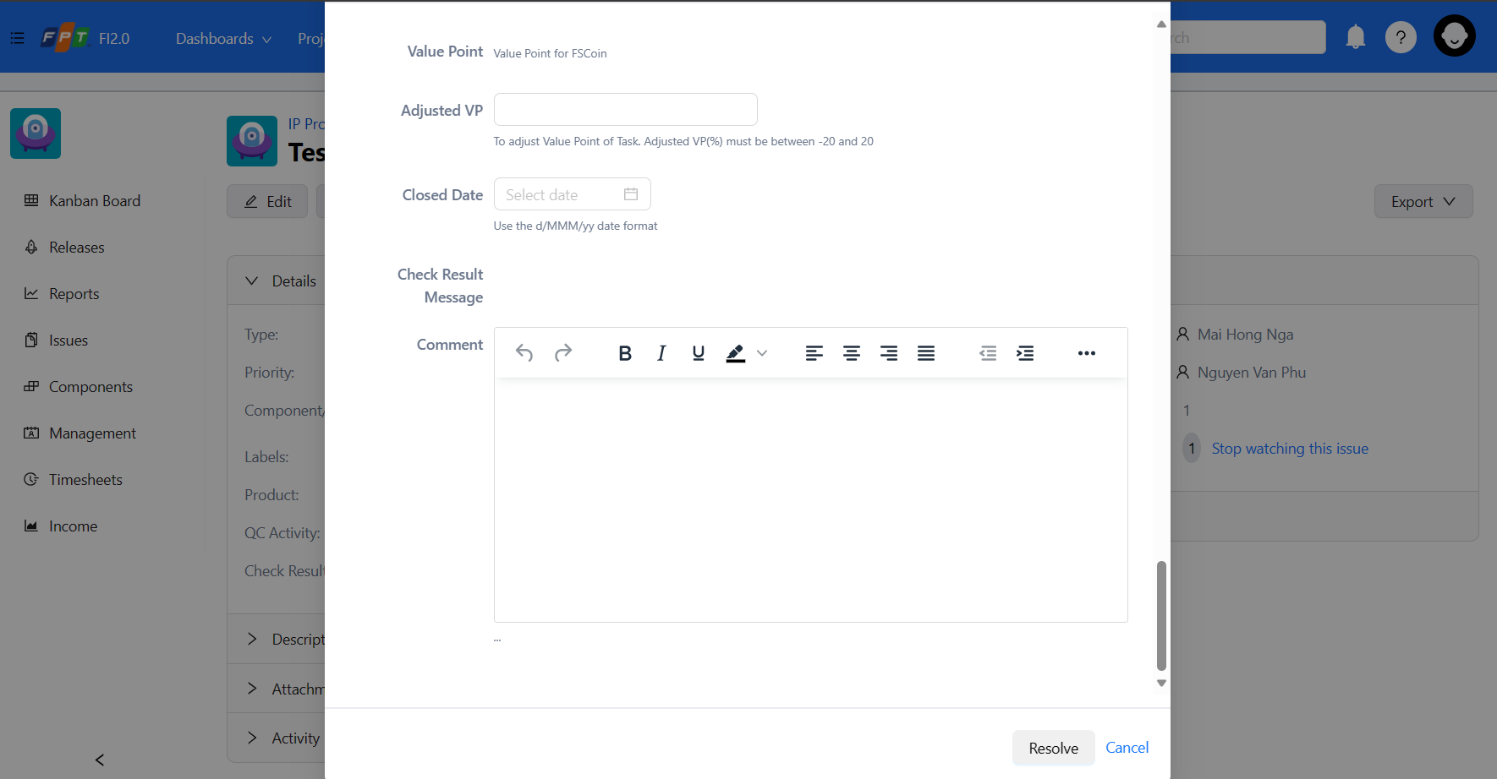

#### *Change the issue’s workflow status to Cancelled*

* Ass User click on Cancelled button on Issue’s workflow status list, a modal of issue’s cancelled status will show up for User to fill.



* After filling information, click on the Cancel on the left button to save.

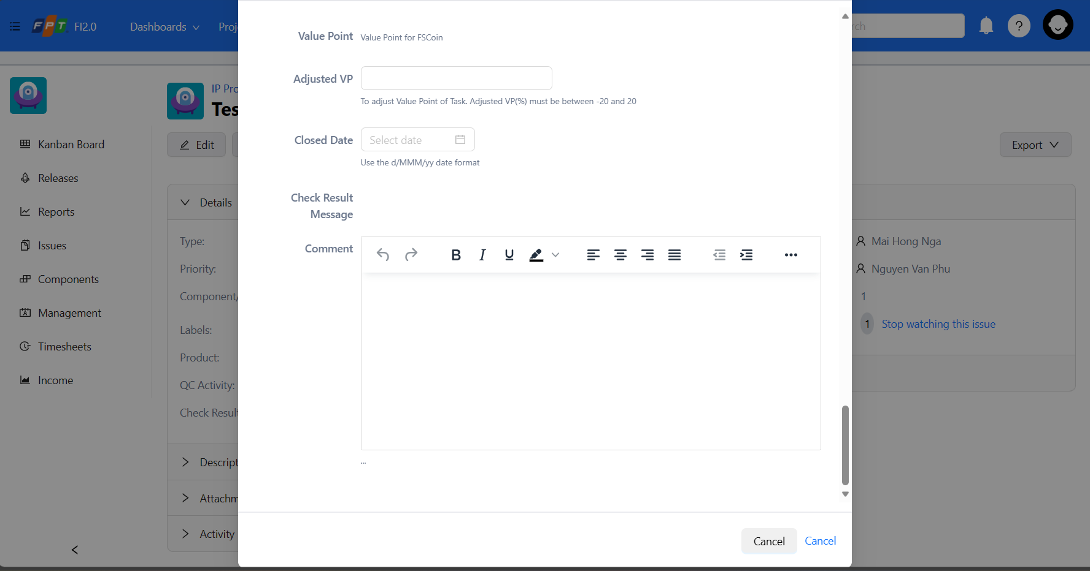

### *Start/ Stop watching the issue.*

* User that logged in the system and want to follow up an issue, User can click on the Start watching this issue button to get all updated information via Jira service email.

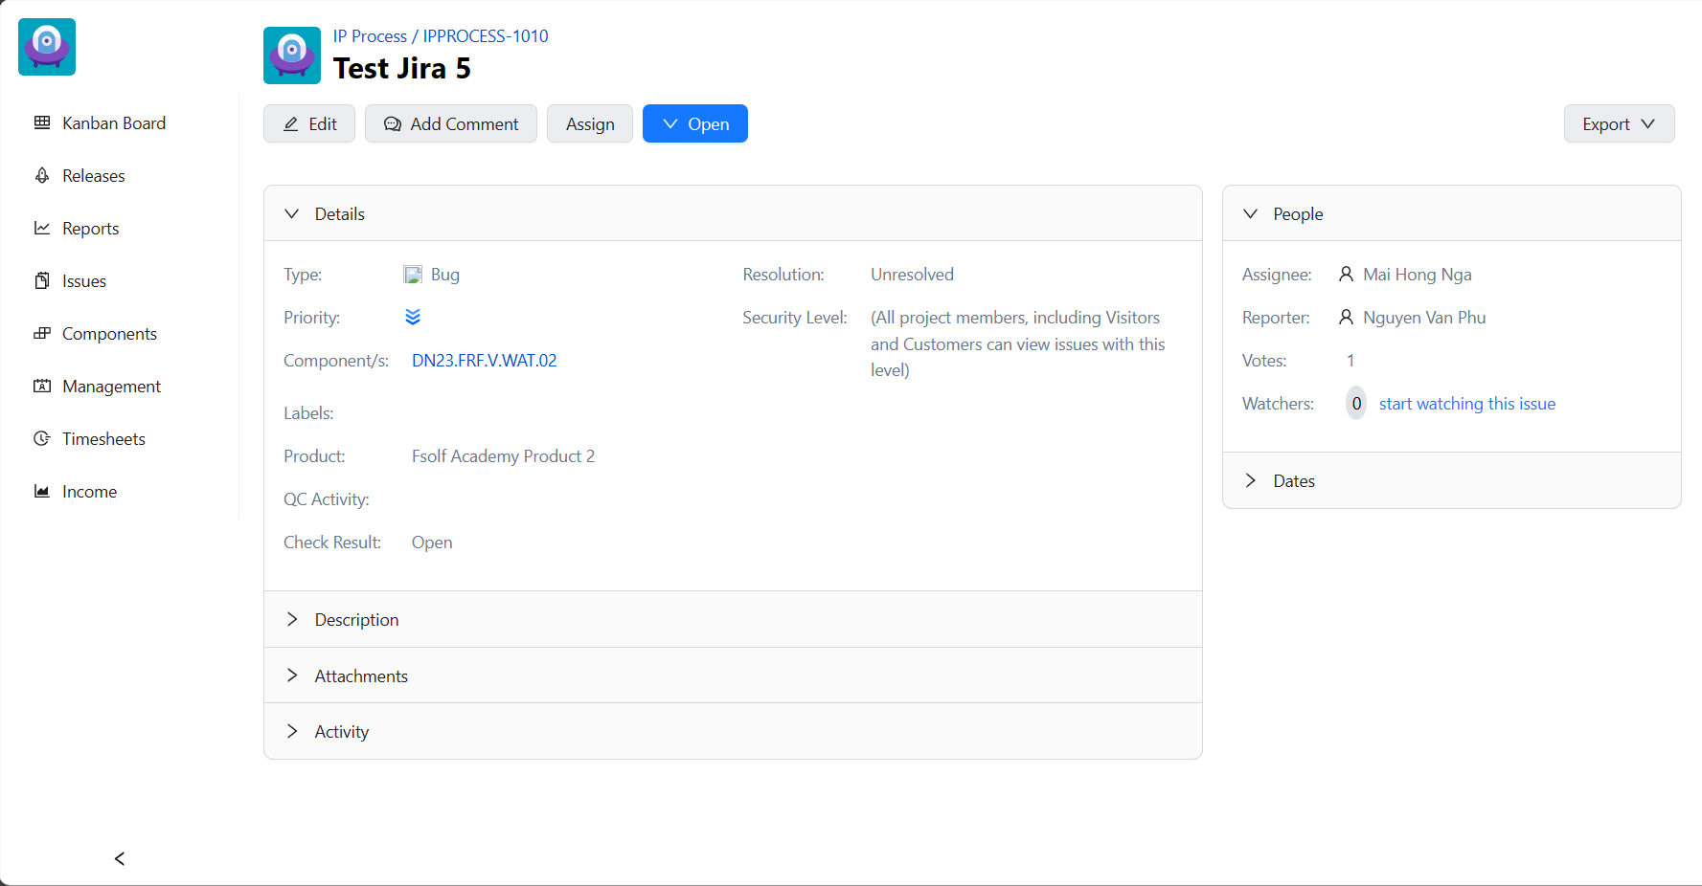

## Personal profile management:

* After Loggin in the Jira system, User go the Profile section on navbar to navigate to personal profile.

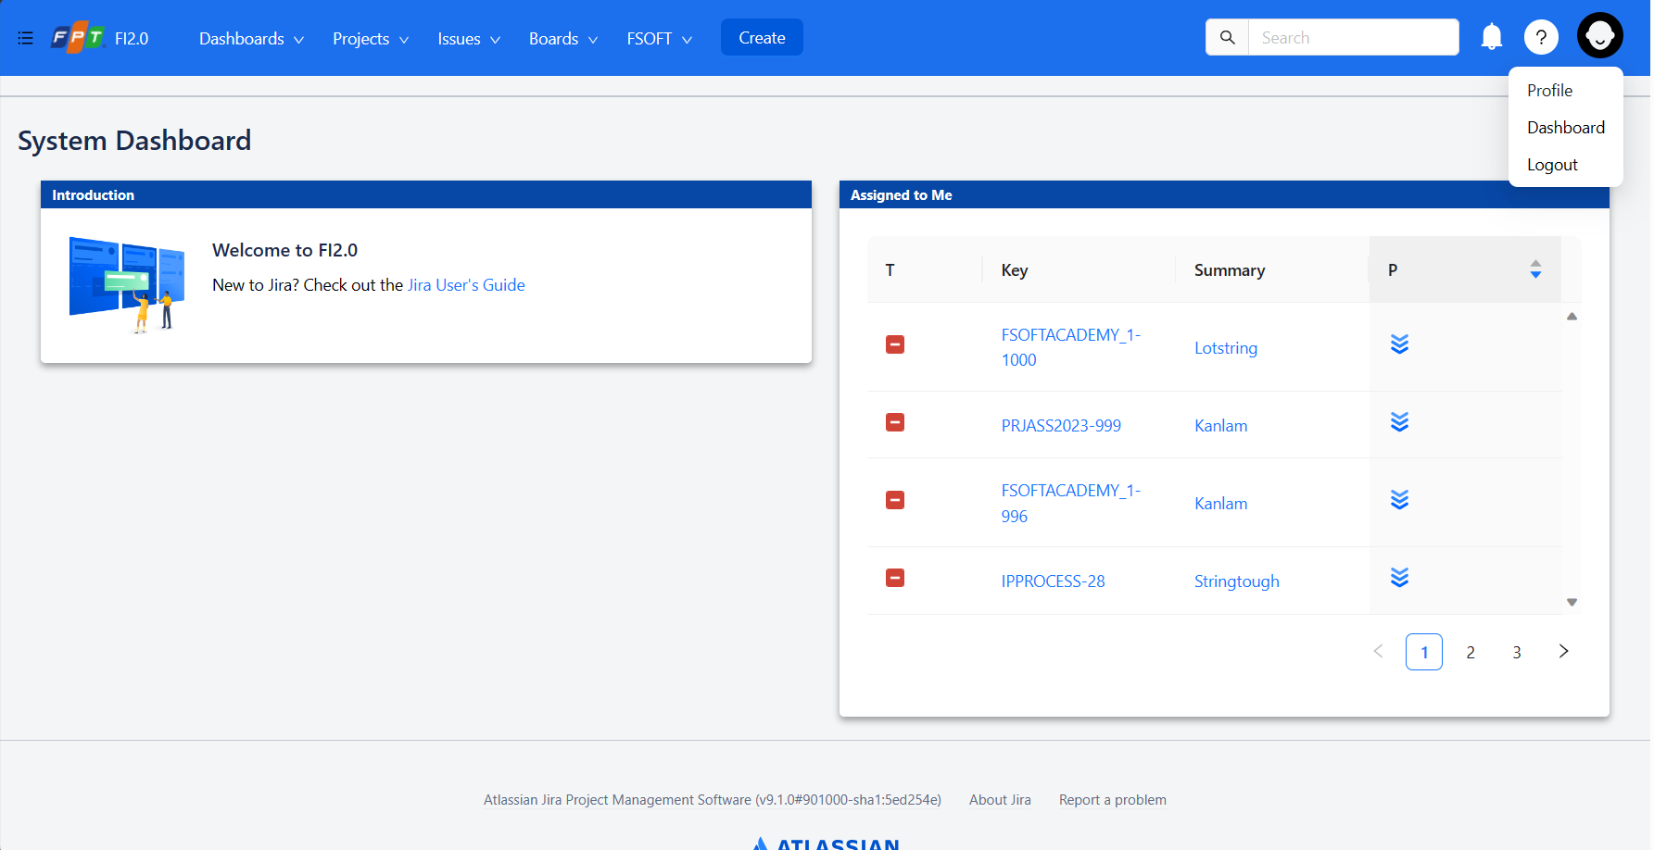

### *View personal information*

* Click on the Profile Button on navbar to navigate to personal profile site.
* User can see all the detail of personal account information.

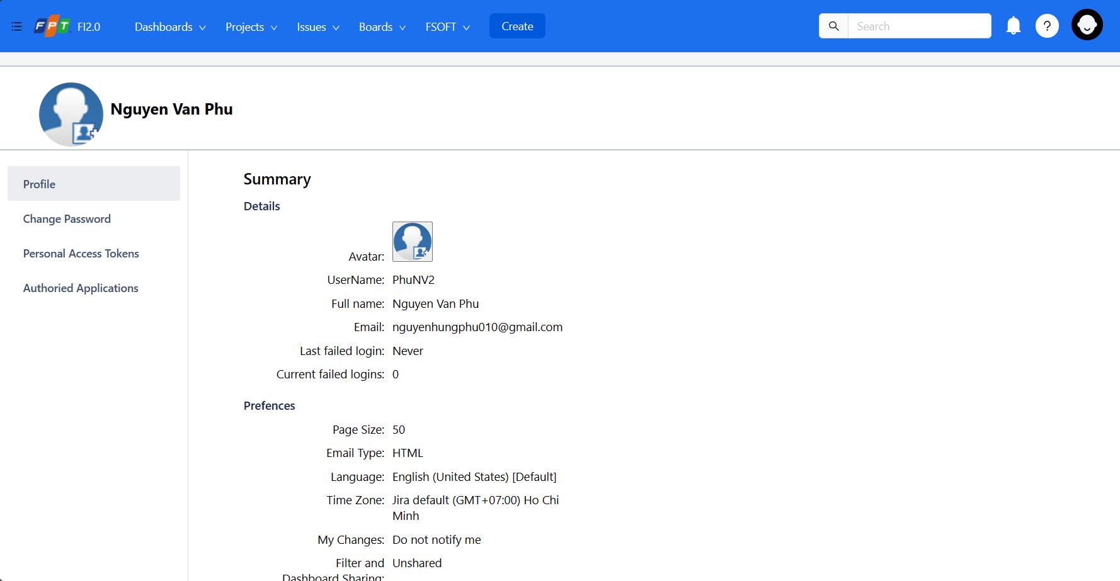

### *Change password*

* User can change the password here, click on the Change Password button on the side bar.



* User type in the New password and Confirmed password that user willing to change.

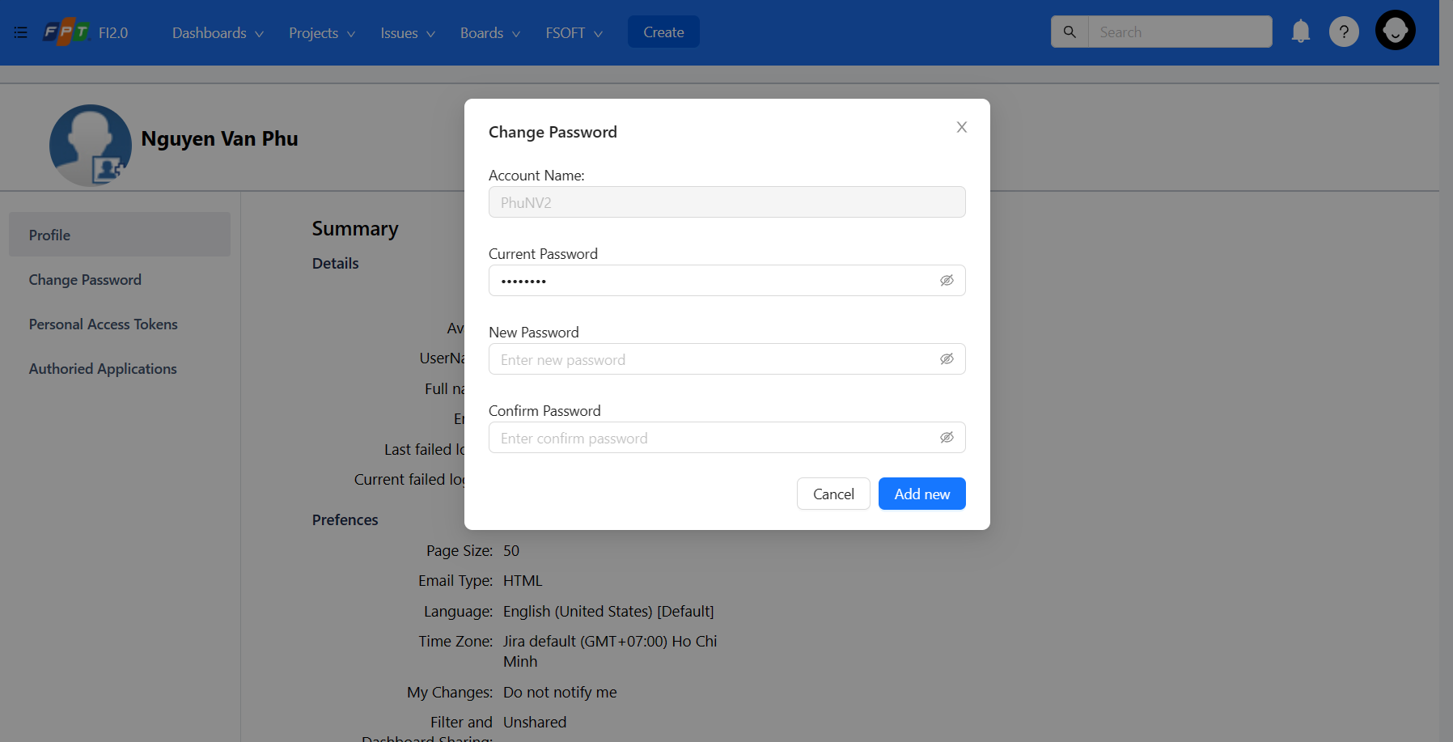

* After filling the password. Click on the Add new Button to save the changed password.

Note:

* Password must be trong. That must include: Number, Uppercase character on the first letter, minimum 6 characters length.

# APPENDIX